Guided Capstone Project Report

The Big Mountain Resort, a ski resort located in Montana, offers spectacular views of Glacier National Park and Flathead National Forest. ~ 350,000 people ski or snowboard at Big Mountain each year. It provides access to 105 trails for skiers and riders of all levels and abilities. It has recently installed a chair lift, which increases the operating costs by $1,540,000 this season. The resort's executive team needs suggestions to develop a strategy to cover this cost, either by charging a premium fee, cutting underused facilities, or other scenarios. Given a data set including 277 peer ski resorts in the US, their facility information, and ticket price, the data science team, evaluated the market competitiveness for the Big Mountain resort, identified the essential features related to the ticket price, and developed potential business strategies to cover the increased cost of the new lift service.

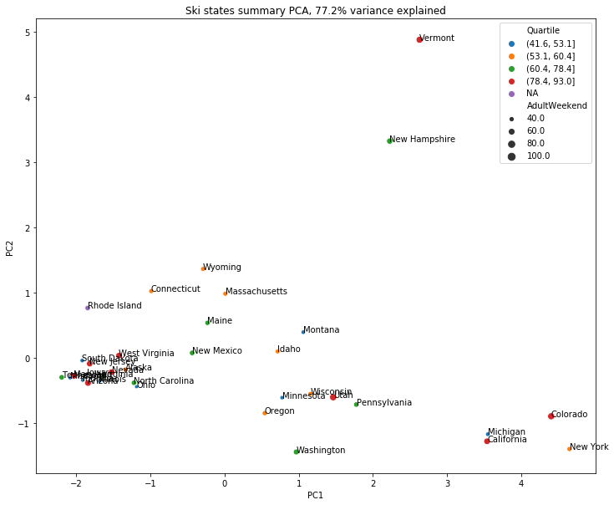First, we evaluated the ski market competitiveness of Montana in the US. Montana is the third largest state in the US with the fourth-largest total skiable area. It is not the most populous state, is not the state with the highest number of ski resorts. It is also not among the top states with the highest total night skiing area and the highest total days open. It's among the top states with the number of ski resorts per 100k capital, but not the leading state with the number of ski resorts per 100k square miles. Considering all state-wise features by principal component analysis, Montana can be listed as the medium top state for skiing in the US, as shown in figure 1. Its average ticket price is near the medium of all the average ticket price in the US.

Fig1. Principle component analysis of Montana as a ski state

Fig1. Principle component analysis of Montana as a ski state

Among 34 numerical features in this study, we identified several import attributes associated with the ticket price based on linear regression and random forest analysis. They are vertical_drop, SnowMaking_ac, total_ chairs, fastQuads, Runs, LongestRun_mi, trams, and SkiableTerrain_ac. The big mountain has excellent vertical_drop, but there are still quite a few resorts with a more significant drop. It is the top resort with high SnowMaking_ac, total_chairs, fastQuads, number of runs, and the most considerable amount of skiable terrain. Like most US resorts and all the other resorts in Montana, the Big Mountains don't offer trams. Thus, it is very competitive in the ski market. Compared with the other resorts, we found the Big Mountain ticket price, $80, is slightly higher than the medium of all the resorts in this study, $60, although it is the most expensive resort in Montana.

Based on the market competitiveness of the Big Mountains and using sophisticated machine learning techniques, we tested several scenarios to cover the increased cost for the new lift, $1,540,000 this season, and gave the following suggestions:

1. Increase the ticket price from $81 to $94.

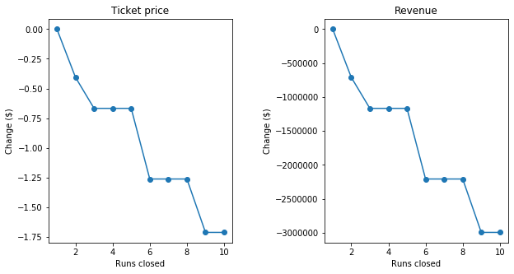As a very competitive contributor in the ski resort market, the Big Mountains' ticket price is still lower than our model predicted value, 94 dollars. Therefore, we suggest increasing the ticket price to 94 dollars, which will increase the revenue by 22,750,000 dollars this season. It can completely cover the cost of the new lift.

Fig2. The change of ticket price and revenue with the change of runs closed predicted by random forest model

2) Close the least used runs. Based on the results in figure 2, we can close the least used run without making a significant difference in the ticket price. We can close up to 4 least used runs with a slight effect on the ticket price, but we may also need to add extra service to support the increase of the ticket price and the close of the runs.

3) Add a new run to increase the vertical drop by 150 feet and install a chair lift. This scenario increases support for ticket price by $8.46. Over the season, this could be expected to amount to $14,811,594.

4) Add two acres of snow making. This scenario increases support for ticket price by $9.75. Over the season, this could be expected to amount to $17,068,841

We can do further analysis to get more detailed business insight, if we do

1. Cluster analysis and market segmentation. Using cluster analysis, we can find similar resorts to the Big mountains and study their price strategy. It may give us more business insights

2. Combine customer information in the study. Our customers have their own evaluation about the current ticket price of the Big Mountains. Their opinion is very important for our business decisions. If we can have customers’ survey data, we can do In-state and out-state customer trend analysis. Based on their age, location and satisfaction, we can do much detailed prediction.

3. Collect social media data. Facebook, twitter and youtube are the most popular platforms for young people. We believe they are also important for our business. If we can collect some data from the social media website about ski lovers, it will be also very helpful for the further analysis too.